

# Acropolis Institute of Technology & Research, Indore

### Department of IT (Information Technology)

A

Synopsis Report On

Minor Project

## Missing Person & Lost Item Tracker

#### Guided By Submitted By

Prof. Dr. Nitin Kulkarni Atharv Sharma(0827IT233D02) Khushi Agrawal (0827IT221076) Harshita Sultanpura (0827RL221006) Dali Vishnav (0827IT221041)

Department of IT (Information Technology) Acropolis Institute of Technology & Research, Indore Session Sep-Jan (2025-26)



# Acropolis Institute of Technology & Research, Indore

### Department of IT (Information Technology)

A

Synopsis Report On

Major Project

## Missing Person & Lost Item Tracker

1. **INTRODUCTION:**

### Overview:

The **Missing Person & Lost Item Tracker** is an innovative, AI-powered digital platform designed to address the challenges associated with locating missing persons and recovering lost items. In today’s increasingly mobile and densely populated society, the frequency of people going missing—be it children wandering off in crowded areas, elderly individuals with memory disorders, or victims of displacement—and the incidence of lost personal belongings are both alarmingly high. Despite numerous existing mechanisms, such as manual FIRs, public announcements, social media posts, and community flyers, there remains a lack of a unified, intelligent, and real-time ecosystem that facilitates rapid identification, efficient alerting, and effective public participation. This project aims to fill that critical void by offering a centralized, secure, and accessible system that enables users to report, search, and assist in recovery operations, powered by advanced technologies such as Artificial Intelligence (AI), facial recognition, object detection, and geolocation services.

Through this platform, users can register incidents by providing descriptive details, uploading photographs, and sharing last-known locations of the missing person or item. The system then stores this information in a secure backend and utilizes **machine learning algorithms** to automatically compare incoming data with existing entries. In the case of missing individuals, facial recognition algorithms analyze the uploaded photos to detect potential matches, while in the case of lost items, object classification models are used to identify similarities between visual descriptions. Additionally, the integration of **Google Maps API** allows for spatial tagging and visual tracking of reports, enhancing situational awareness. When the system detects a probable match, it instantly sends **alerts to nearby users and verified authorities** using Firebase or Twilio, facilitating immediate action. The platform also supports administrative functionalities for law enforcement or NGOs to validate cases, update statuses, and close resolved incidents. By transforming traditional search processes into a smart, community-driven, and AI-augmented experience, this project has the potential to revolutionize how we respond to one of society’s most emotionally and logistically complex issues.

### Purpose of the Project/Innovativeness and usefulness:

* + - **Assist in Finding Missing Persons and Lost Items:** The primary objective of the project is to provide a centralized platform that enables users to report missing individuals or lost belongings quickly and efficiently. The system bridges the communication gap between the person searching, the general public, and authorities.
    - **Leverage Artificial Intelligence for Smart Matching:** By utilizing AI algorithms such as facial recognition for missing persons and object detection for lost items, the platform ensures intelligent and automated comparison of submitted reports to increase the chances of successful recovery.
    - **Enable Real-Time Alerts and Geo-Tracking:** The platform integrates with geolocation services (e.g., Google Maps API) and push notification systems (e.g., Firebase, Twilio) to issue immediate alerts to nearby users and authorities when a potential match is found, increasing the response speed in critical situations.
    - **Promote Community Participation:** The application empowers the general public to actively contribute to recovery efforts by enabling them to submit sightings, match reports, and stay informed about nearby incidents, thus building a strong community-driven support system.
    - **Support Verified Intervention by Authorities:** The system includes an admin dashboard where police officers, NGOs, or security officials can review, verify, and update case statuses, adding a layer of authenticity, control, and follow-through in the recovery process.
    - **Scalable and Adaptable Across Sectors:** The solution is modular and can be implemented across various environments such as schools, transport hubs, shopping malls, large events, or even smart city safety networks, making it highly versatile and scalable.
    - **Improve Accuracy and Minimize False Alarms:** With intelligent data processing, normalization, and AI-assisted decision-making, the system aims to reduce false positives and ensure that alerts are relevant, reliable, and timely.
    - **Enhance Trust and Safety in Society:** By ensuring that lost and missing reports are handled professionally and effectively, the project fosters public trust in digital civic safety systems and helps create a safer, more connected society.

## Literature Survey:

### Existing Problem:

#### Lack of Centralized Reporting Platforms:

Currently, there is no unified system where people can report missing individuals or lost items. Reports are scattered across social media, police records, and informal networks.

#### Manual and Time-Consuming Search Methods:

Traditional approaches involve printing posters, filing physical reports, or word-of-mouth campaigns—all of which are slow and offer limited reach and responsiveness.

#### Absence of Smart Matching Capabilities:

Most existing systems do not use intelligent matching techniques like facial recognition or object detection, leading to missed connections and lower recovery rates.

#### Limited Public Participation:

Community involvement is minimal due to lack of awareness, accessibility, or real-time notification systems that engage people nearby when a case is reported.

#### No Real-Time Alert Mechanism:

There is no system that provides instant alerts to nearby users or authorities when someone is reported missing or an item is found.

#### Inefficiency in Data Handling:

Existing systems are often not optimized for handling large volumes of multimedia reports, real- time comparisons, or location-based filtering.

### 2.2 Proposed Solution:

#### Development of a Centralized Reporting System:

A unified digital platform (web and mobile) where users can register missing persons or lost items by submitting images, location, descriptions, and time details.

#### Integration of AI for Smart Matching:

Use of facial recognition algorithms for identifying missing individuals and object classification techniques for matching lost items with found reports.

#### Implementation of Geolocation-Based Alert System:

Integration with Google Maps API and Firebase/Twilio to send real-time location-based alerts to nearby users or relevant authorities when a match is detected.

#### Public Participation and Community Reporting:

Enabling every user to act as a potential observer, allowing them to report sightings and contribute to real-time tracking and recovery efforts.

#### Role-Based Access for Verification:

Special admin dashboards for law enforcement, NGOs, or campus authorities to verify reports, manage ongoing cases, and resolve or close entries once the person or item is found.

#### Scalable and Modular Architecture:

The system is designed to be easily deployable across various sectors—like transport hubs, educational institutions, malls, or public events—making it adaptable to multiple use cases.

#### Secure and Privacy-Focused Design:

Ensures that user data is encrypted, reports are moderated, and privacy of reporters and subjects is maintained while still enabling efficient search capabilities.

## Theoretical Analysis:

### Block Diagram:

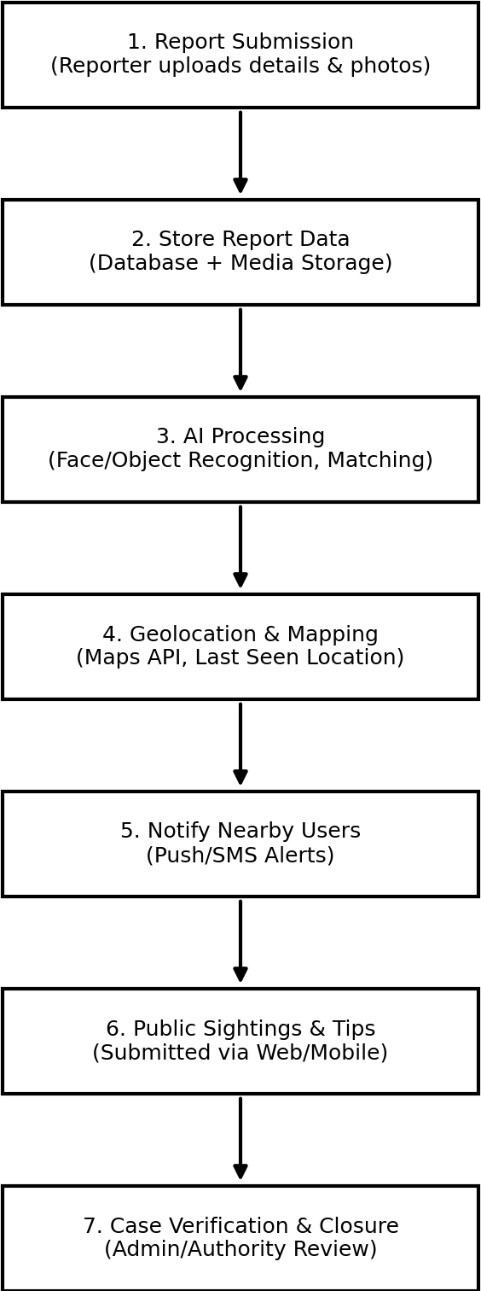

Fig. 3.1.1 Flow Control Diagram.

### Required Resources:

#### Hardware Requirements:

* + - Laptop/Desktop:
      * Processor: Intel i7 / AMD Ryzen 7 (8th Gen or above)
      * RAM: Minimum 16 GB (32 GB recommended)
      * GPU: NVIDIA GTX 1660 / RTX 3060 or higher (for AI training)
      * OS: Windows 10/11 or Ubuntu 20.04+
    - Storage:
      * SSD (512 GB or more) for faster data processing
      * Optional: Google Cloud / Firebase Storage for cloud backup

#### Software Requirements:

* + - Languages:
      * Python 3.10, Java JDK 17
    - Libraries & Frameworks:
      * TensorFlow 2.13.0, OpenCV 4.8.0
      * Scikit-learn 1.3.0, Pandas 2.0.3, NumPy 1.25.2
    - Frontend:
      * ReactJS 18.2.0 or Flutter 3.10.5
    - Backend:
      * Spring Boot 3.1.2 (Java)
    - Databases:
      * MongoDB 6.0 (NoSQL)
      * PostgreSQL 15.3 (optional, relational)
    - APIs & Services:
      * Google Maps API (geolocation)
      * Firebase (Auth, Realtime DB, Cloud Messaging)
      * Twilio API (SMS alerts)

## Applications:

#### Law Enforcement & Police Departments:

Enables quick reporting, tracking, and verification of missing person cases. Helps in automating match detection and issuing public alerts.

#### Hospitals & Care Homes:

Useful for tracking elderly or mentally challenged individuals who may wander off or get separated from guardians.

#### Schools, Colleges & Hostels:

Helps in locating lost student items (bags, ID cards, books) and managing missing student alerts during field trips or events.

#### Airports, Railway Stations & Bus Terminals:

Tracks unclaimed baggage, lost documents, and even missing persons in high-traffic public transportation areas.

#### Large Public Events & Festivals:

Offers real-time alerting and recovery of lost items and children during crowded gatherings and functions.

#### Corporate & Commercial Buildings:

Assists in internal lost-and-found tracking systems for employee or visitor belongings.

#### Integration with Civic Safety Apps:

Can be integrated with smart city apps or community security networks to enhance urban safety infrastructure.

## References:

#### Google Maps API Documentation

https://developers.google.com/maps/documentation

#### OpenCV Documentation

https://docs.opencv.org/master/

#### Firebase Cloud Messaging (FCM) Docs

https://firebase.google.com/docs/cloud-messaging

#### Twilio Messaging API

https://[www.twilio.com/docs/messaging](http://www.twilio.com/docs/messaging)

1. **Face Recognition Using Deep Learning: A Review** – IEEE Xplore https://ieeexplore.ieee.org/document/9449828

#### Kaggle – Missing Person Data Sets

https://[www.kaggle.com/datasets/iamsouravbanerjee/missing-persons-dataset](http://www.kaggle.com/datasets/iamsouravbanerjee/missing-persons-dataset)

#### TensorFlow Documentation

https://[www.tensorflow.org/](http://www.tensorflow.org/)

#### Pandas Documentation (Data Preprocessing)

https://pandas.pydata.org/docs/

#### MongoDB Official Docs

https://[www.mongodb.com/docs/](http://www.mongodb.com/docs/)

#### Real-Life Missing Persons Statistics – NCRB India

https://ncrb.gov.in/en/crime-india